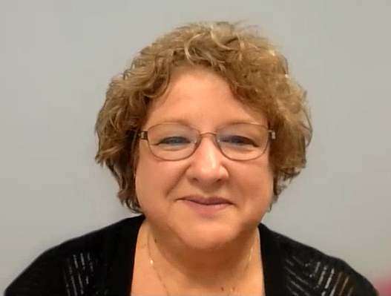

Hi. My name is Lisa Fusco and I’m the Director of Finance at St. Brendan Parish in North Olmsted. I’d like to share a few words of encouragement with you about the Angel Scholarship Fund. We’ve been able to grow our designated ASF funds over the years, and I know you can, too!

Our number one priority with ASF is getting parents and Parishioners to understand that this is the best fundraising opportunity that won’t ultimately cost them a dime. ASF is allowing us to raise tuition without raising the parent’s out-of-pocket tuition payments which is decreasing our dependency on Parish Collections subsidies.

I think for us it all started with talking to the Parents in January of 2025. We had a parent meeting explaining that we were raising tuition almost $1,500 a child but through Angel Scholarship, they could fund that gap without it coming out of their pocket. We gave them the instructions on how to do it and then promoted it at all the Masses. We showed everyone that if they prepared their taxes but did not immediately file them, they could find the maximum amount they could donate. Once they determined how much they could donate we said to make the donation on their credit card right after their billing cycle started. Once the donation was made, they would update their taxes with the donation and file them immediately. Their refund would come to them before their credit card was due and they could then pay it off. If they had a cashback credit card, they could actually make money on the transaction. The first year we almost made our goal of $200,000. This year we set a goal of $225,000 and we exceeded it by raising $235,000. Once everyone understood how it worked and saw it in action the second year’s campaign sort of ran itself.

It’s also important to send Thank you notes. We’ve had many Parishioner’s from all 3 parishes tell us that the thank you notes from the children made all the difference to them and they even increased their contribution the second year because of it. We have the children handwrite thank you notes to everyone who donated (except parents and staff). We then follow those up with a Thank you letter from Fr. Tom. This is sent to all donors.

Our plans to promote ASF this year are to continue our Annual Campaign that starts in December and runs through April 15th. We plan to have our parents do the presentations at all the Masses and continue to have the children at those Masses in uniform passing out the Donation Application and instructions. We also plan to ramp up our social media to get the word out. We will continue to have benchmark prizes for the children in the school and will continue encouraging the parents to be ambassadors and spread the word.

Our pastor, Fr. Tom Woost, will tell you we are blessed to have a great relationship between all three North Olmsted parishes, and that parishioners have really taken ownership of Catholic education and see St. Brendan School as their own. Fr. Tom works with Deacon Mike at St. Richard’s and Fr. Neil at St. Clarence. All three Parishes are partnered together in the Keeping the Faith Program so St. Brendan is their school. They are gracious in allowing us to make an annual in-person appeal and pass out the information. We provide school updates in their bulletins throughout the year, and we put the Angel Articles in their bulletins as well during our campaign. We are blessed with a great collaborative Catholic Community in North Olmsted!

ASF has been an easy and great way to enhance our school and strengthen the Catholic faith within our youth.

I encourage all pastors and especially business managers to go “all in” with ASF as a great way to raise revenue without an adding tuition cost for school families.

