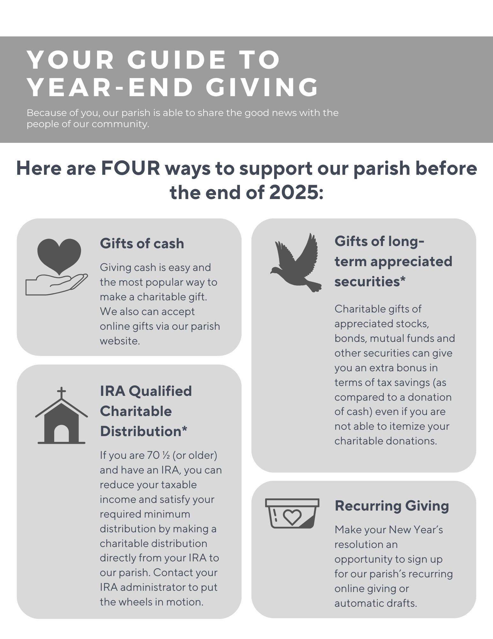

Please contact XX in our parish office at XXX-XXX-XXXX or visit our parish website at XXXXXXX for more information.

*For more information on gifting long-term appreciated securities or making an IRA Qualified Charitable Distribution, please contact Moira Wopershall at the Catholic Community Foundation at 216-696-6525 x 8070 or visit CatholicCommunity.org/year-end-giving.

